Flame light

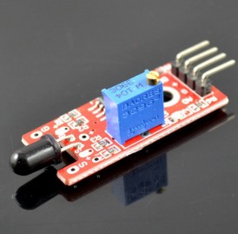

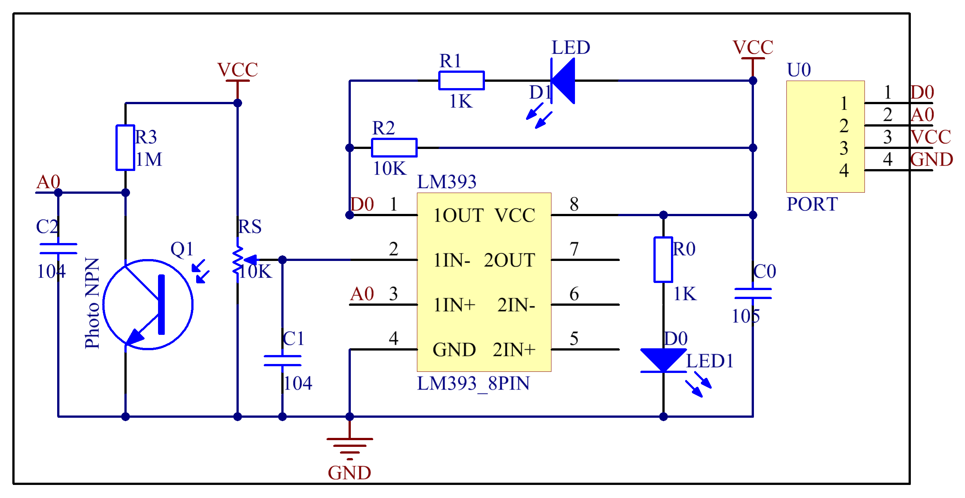

Components
-1 * KUMAN Uno board
- 1 * USB data cable
- 1 * Flame sensor module
- 1 * LED
- 1 * 4-Pin anti-reverse cable
- 1 * 3-Pin anti-reverse cable

This project will use a flame sensor to detect fire. When fire flame is detected, LED in the circuit will turn on.
Step 1: Connect fire sensor to Arduino as per following graph:
The wiring between the flame sensor and KUMAN Uno board:

Flame Sensor | KUMAN Uno
D0 | 8
A0 | A0
VCC | 5V
GND | GND

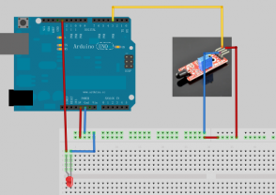

CODE:

/* Fire sensor module test project

int Led=13;
int buttonpin=3;
int val;
void setup()
{
pinMode(Led,OUTPUT);
pinMode(buttonpin,INPUT);
}
void loop()
{
val=digitalRead(buttonpin);
if(val==HIGH)
{
digitalWrite(Led,HIGH);
}
else
{
digitalWrite(Led,LOW);
}
}

